Fewer Ohio counties sharing in employment growth

For most of Ohio’s history, the state’s 88 counties shared in the job growth during the expansions that followed each recession. For example, all but 10 counties posted record high employment in 1979, 1980 or 1981, the three years bracketing the January 1980 peak of the 1973-1980 business cycle. Those 78 counties represented 96 percent of the state’s total population, according to the 1980 census.
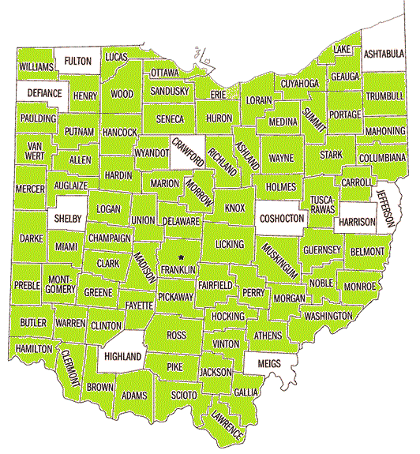

The pattern of shared job growth continued in the next two business cycles. In the three years bracketing the July 1990 peak, 66 counties, representing about 86 percent of the state’s population, posted record high employment.
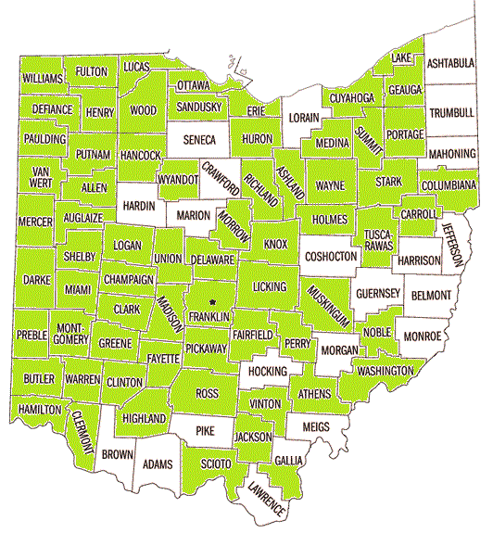

In the three years bracketing the March 2001 peak, 56 counties, representing about 73 percent of the state’s population, posted record high job counts.
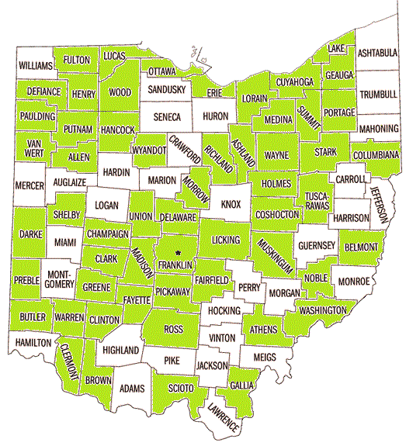

But the job growth trend changed dramatically following the 2001 recession, when only 24 of the 88 counties, representing about 27 percent of the population, saw record expansion in the three years bracketing the December 2007 peak of the expansion.
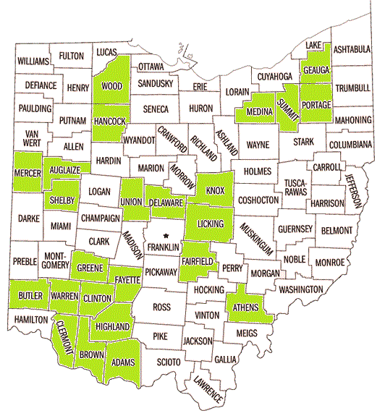

The pattern of a minority of Ohio counties experiencing robust employment growth continued after the most recent recession, which officially ended in June 2009. In the last three years, only 20 Ohio counties, representing about 30 percent of the state’s population, posted record high employment.
